EXEMPTION CERTIFICATE DURING LOCKDOWN
Pursuant to the decree n°2020-1310 of October 29th, 2020 prescribing rues necessary in the fight against the spread of the Covid-19 virus
I, the undersigned,
Ms/Mr:
Born on:
In:
Address:
certify that my reasons to be outdoors match one of the following situations (check the box) authorised by the decree n°2020-1310 of October 29th 2020 to tackle the spread of Covid-19 as part of the state of health emergency:
Commuting to and from work or university and training places; for a competition or an exam ; business trips that cannot be delayed.
Running necessary errands to purchase items for professional activity, or basic commodities available in the businesses allowed to provide service, order withdrawal or home deliveries
Consults and provision of care that cannot be done remotely; medication purchase
Imperative family reasons, assisting vulnerable persons, persons in a precarious situation or taking care of children.
Persons with a disability and their accompanying person
Outdoor activities to practice sport individually or for leisure (collective physical activity and proximity to others are not allowed), with no change in the place of residence, walking out with only the people living in the same household or walking out a pet, within 20km of one’s place of residence and for three hours per day
Judicial or administrative summons; appointment to public service offices
Participating in a mission of general interest upon request from an administrative authority
Taking children to and picking them up from school or after-school activity
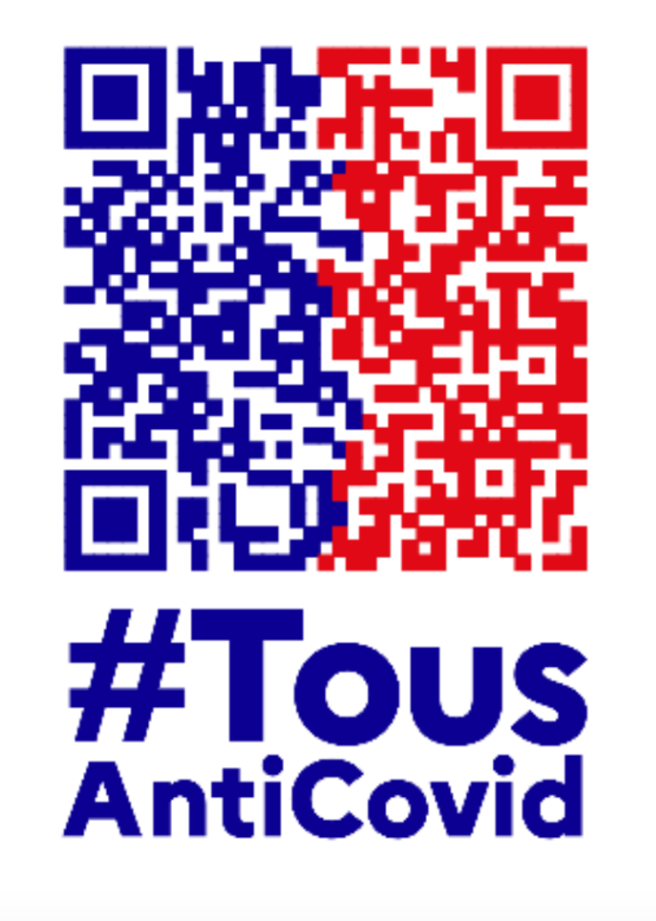
To fight against the spread, download

Signed in
On: at
(Date and time are mandatory)
Signature:

People whose situation matches one of the aforementioned and can therefore be exempt must carry, when outdoors, written proof to justify that exemption.
To be used by self-employed workers, when they cannot get a travel document from their employer.
Including the acquisition of free commodities (food distribution, etc.) and trips related to the receipt of social benefits and cash withdrawals

